1) Create a ConfigMap from a directory containing multiple files and inject the variables into a pod as environment variables

Step 1: Create a directory with config files
Create a folder and add multiple files:
mkdir app-config
cd app-config

Create files:
echo "DB_HOST=localhost" > db.env
echo "DB_PORT=5432" >> db.env
echo "APP_MODE=production" > app.env
echo "APP_DEBUG=false" >> app.env

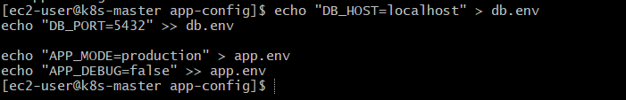
Now your directory looks like:
app-config/
├── db.env
└── app.env

Step 2: Create ConfigMap from directory
Use this command:
kubectl create configmap my-config --from-file=.

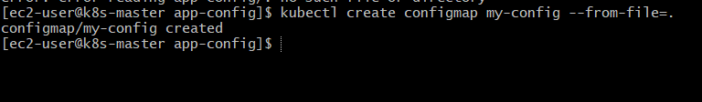
Verify:
kubectl get configmap my-config
kubectl describe configmap my-config

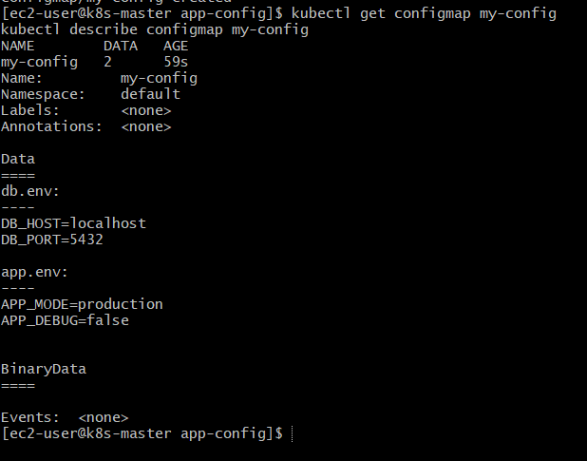

Step 3: Understand what happened
Kubernetes stored files like:
db.env -> contains DB_HOST, DB_PORT
app.env -> contains APP_MODE, APP_DEBUG
Important:
These are stored as file content, NOT directly as env variables yet.

Step 4: Create Pod YAML
Now we inject them as environment variables.
Create a file:
vi pod.yaml

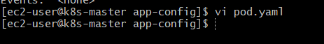
Paste this:
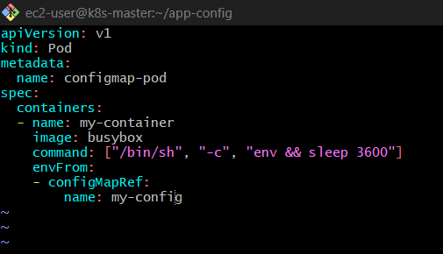
apiVersion: v1
kind: Pod
metadata:
name: configmap-pod
spec:
containers:
- name: my-container
image: busybox
command: ["/bin/sh", "-c", "env && sleep 3600"]
envFrom:
- configMapRef:
name: my-config

Step 5: Apply Pod
kubectl apply -f pod.yaml

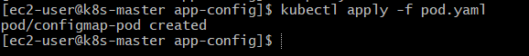
Check:
kubectl get pods

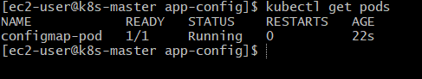

Step 6: Verify Environment Variables
kubectl exec -it configmap-pod – env

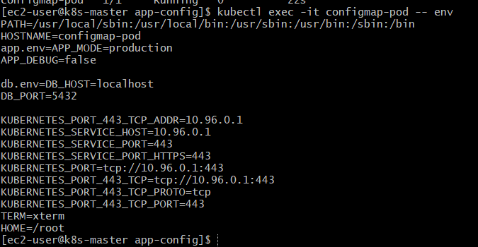

Important Reality Check
This method WON’T properly split variables from .env files.
You’ll see something like:
db.env=DB_HOST=localhost
DB_PORT=5432
NOT:
DB_HOST=localhost
DB_PORT=5432

Correct Way (Best Practice)
To properly inject env variables, use --from-env-file

Step 7: Create ConfigMap properly

kubectl create configmap my-config-env \
--from-env-file=db.env \
--from-env-file=app.env
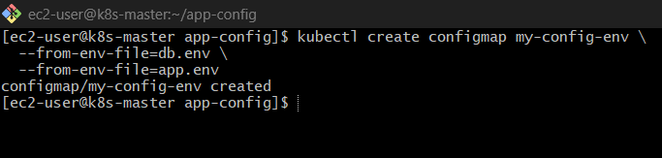

Step 8: Update Pod YAML
apiVersion: v1
kind: Pod
metadata:
name: configmap-pod-env
spec:
containers:
- name: my-container
image: busybox
command: ["/bin/sh", "-c", "env && sleep 3600"]
envFrom:
- configMapRef:
name: my-config-env

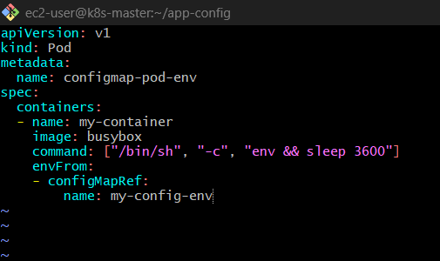

Step 9: Apply & Verify

kubectl exec -it configmap-pod-env -c my-container – env
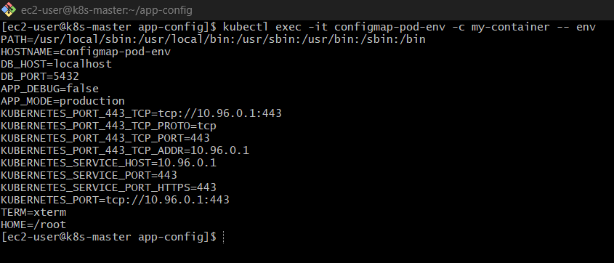

kubectl apply -f pod.yaml

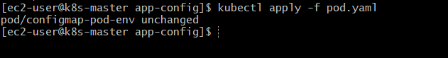
Now you’ll correctly get:
DB_HOST=localhost
DB_PORT=5432
APP_MODE=production
APP_DEBUG=false

Final Summary
- --from-file → stores files as keys (not env vars directly)
- --from-env-file → converts key=value → real env variables
- envFrom + configMapRef → injects all variables into pod

2) Create a ConfigMap from a file and mount it as a volume inside a pod, ensuring the configuration data is available as file

Step 1: Create a configuration file
Create a simple config file:
echo "APP_COLOR=blue" > app.properties
echo "APP_MODE=production" >> app.properties

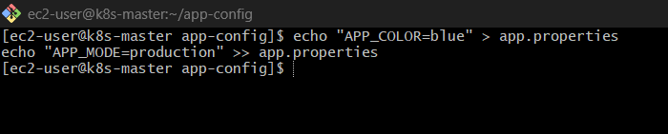
👉 File content:
APP_COLOR=blue
APP_MODE=production

Step 2: Create ConfigMap from file
kubectl create configmap app-config --from-file=app.properties

Verify:
kubectl describe configmap app-config

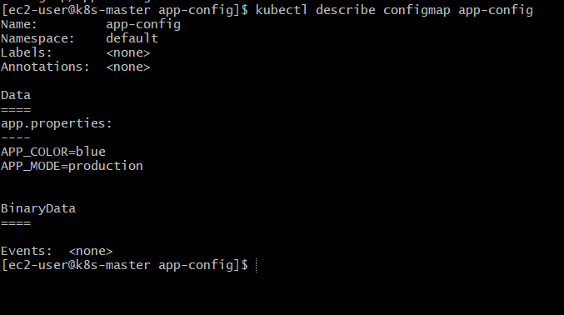
👉 Inside ConfigMap:
app.properties:
APP_COLOR=blue
APP_MODE=production

Step 3: Create Pod YAML with Volume Mount
Create file:
vi pod-configmap.yaml

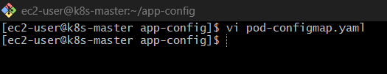
Paste this:

apiVersion: v1
kind: Pod
metadata:
name: configmap-volume-pod
spec:
containers:
- name: my-container
image: busybox
command: ["/bin/sh", "-c", "sleep 3600"]
volumeMounts:
- name: config-volume
mountPath: /etc/config # directory inside container
volumes:
- name: config-volume
configMap:
name: app-config
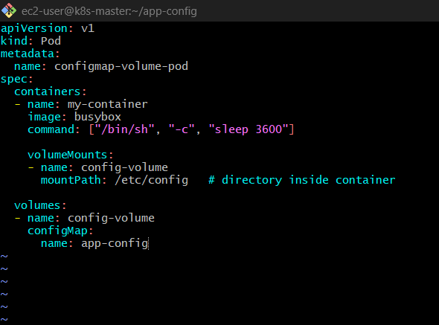

Step 4: Apply the Pod
kubectl apply -f pod-configmap.yaml

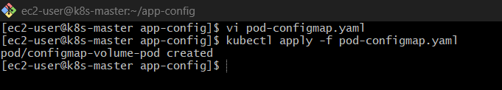
Check:
kubectl get pods

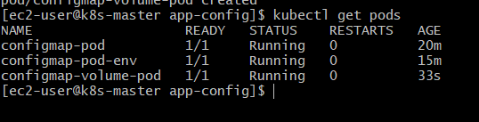

Step 5: Verify inside the container
Enter the pod:
kubectl exec -it configmap-volume-pod – sh

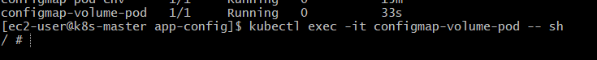
Check files:
cd /etc/config
ls

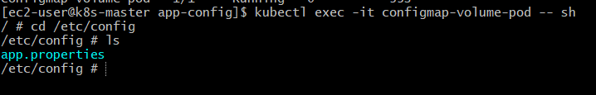
👉 Output:
app.properties
View file:
cat app.properties

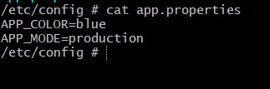

👉Output:
APP_COLOR=blue
APP_MODE=production

Key Concept (VERY IMPORTANT)
- ConfigMap as volume → data appears as files
- File name = key name (app.properties)
- File content = actual config data

Bonus
If you want custom file name, use this:
volumes:
- name: config-volume
configMap:
name: app-config
items:
- key: app.properties
path: custom-config.txt

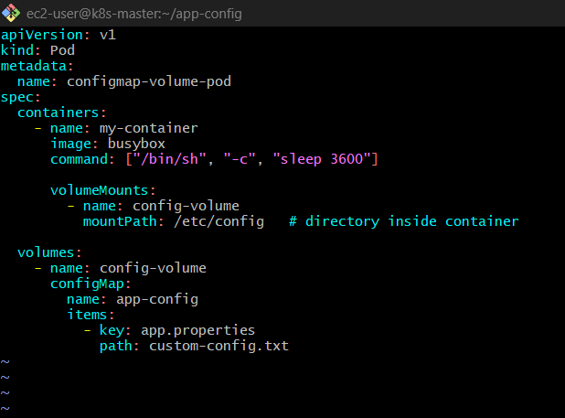
Now inside container:
/etc/config/custom-config.txt
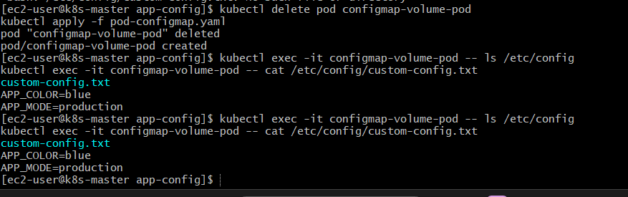

Final Summary
- --from-file → creates ConfigMap from file
- volumeMounts → where it appears in container
- volumes.configMap → link ConfigMap to pod
- Data available as file (not env variables)

3) Create a Secret with sensitive information (username and password) and inject it into a pod as environment variables.

Step 1: Create Secret (username & password)
You can create a Secret in two ways:
Method 1: Direct (recommended)
kubectl create secret generic my-secret \
--from-literal=username=admin \
--from-literal=password=MyStrongPass123

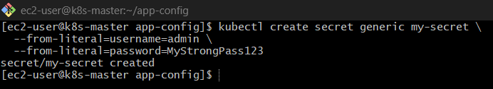

Verify Secret
kubectl get secret my-secret
kubectl describe secret my-secret

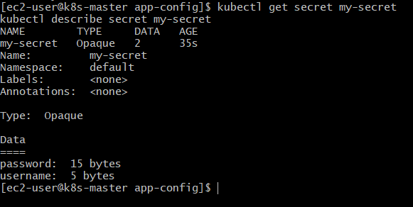
👉 Values are base64 encoded (security purpose)

Step 2: Create Pod YAML
Create file:
vi secret-pod.yaml
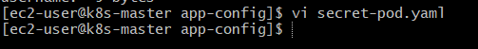
Paste this:
apiVersion: v1
kind: Pod
metadata:
name: secret-env-pod
spec:
containers:
- name: my-container
image: busybox
command: ["/bin/sh", "-c", "env && sleep 3600"]
env:
- name: USERNAME
valueFrom:
secretKeyRef:
name: my-secret
key: username
- name: PASSWORD
valueFrom:
secretKeyRef:
name: my-secret
key: password

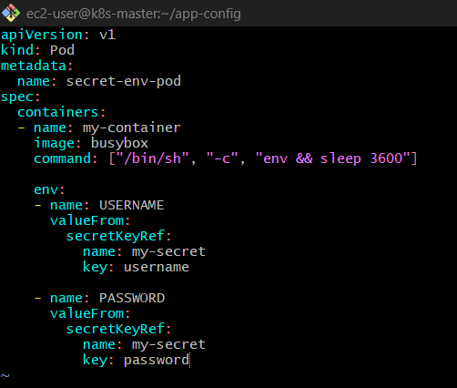

Step 3: Apply the Pod
kubectl apply -f secret-pod.yaml

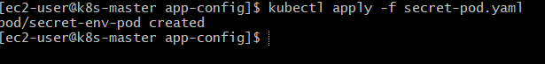
Check:
kubectl get pods

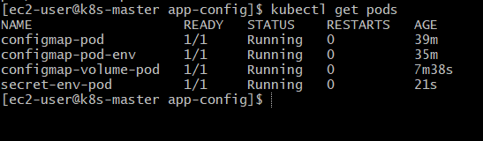

Step 4: Verify Environment Variables
kubectl exec -it secret-env-pod – env

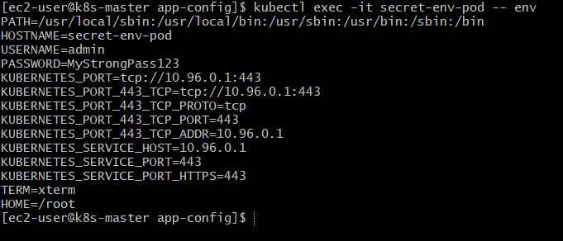
👉 Output will include:
USERNAME=admin
PASSWORD=MyStrongPass123

Alternative Method (Inject all at once)
Instead of defining one-by-one, use envFrom:
envFrom:
- secretRef:
name: my-secret
👉 This injects ALL keys automatically:
- username → USERNAME (if you name it uppercase)
- password → PASSWORD
Pod YAML
apiVersion: v1
kind: Pod
metadata:
name: secret-envfrom-pod
spec:
containers:
- name: my-container
image: busybox
command: ["/bin/sh", "-c", "env && sleep 3600"]
envFrom:
- secretRef:
name: my-secret

What this does
👉 This line:
envFrom:
- secretRef:
name: my-secret
means:
✔ Take all keys from Secret my-secret
✔ Convert them into environment variables inside the container

Example Secret
If your Secret was created like this:
kubectl create secret generic my-secret \
--from-literal=username=admin \
--from-literal=password=MyStrongPass123
Inside the Pod (Result)
When you run:
kubectl exec -it secret-envfrom-pod -- env
You’ll see:
username=admin
password=MyStrongPass123

Important Gotcha
👉 Kubernetes does NOT automatically uppercase keys
So:
Secret Key | Env Variable
username | username
password | password
❌ NOT:
USERNAME
PASSWORD

If you WANT uppercase variables
You must define manually like this:
env:
- name: USERNAME
valueFrom:
secretKeyRef:
name: my-secret
key: username

When to use what
Method | Use Case
envFrom | Load all variables quickly
env + secretKeyRef | Need control / rename variables

Important Concepts
✔ Secret stores sensitive data (unlike ConfigMap)
✔ Data is base64 encoded (not fully encrypted by default)
✔ Use:
- env → for specific keys
- envFrom → for all keys

Real-World
- Avoid hardcoding secrets in YAML
- Use:
  - External secret managers (AWS Secrets Manager, Vault)
  - Kubernetes RBAC for protection

Final Summary
Feature | ConfigMap | Secret
Data type | Normal config | Sensitive data
Encoding | Plain text | Base64 encoded
Usage | Env / Volume | Env / Volume

4) Create a Secret using a YAML file, mount it as a volume in a pod, and verify the specific Secret values are available as files.

Step 1: Create Secret YAML file
Create a file:
vi secret.yaml
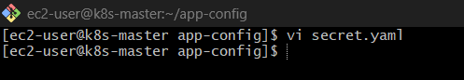
Paste this:
apiVersion: v1
kind: Secret
metadata:
name: my-secret-yaml
type: Opaque
data:
username: YWRtaW4= # base64 for "admin"
password: TXlQYXNzMTIz # base64 for "MyPass123"

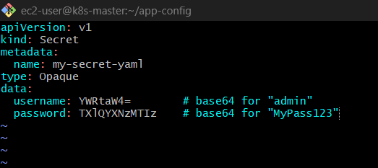

How did we get base64 values?
echo -n "admin" | base64
echo -n "MyPass123" | base64
Output used in YAML.
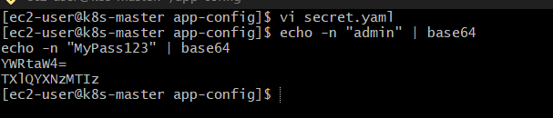

Step 2: Apply Secret
kubectl apply -f secret.yaml

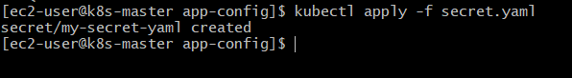
Verify:
kubectl get secrets
kubectl describe secret my-secret-yaml

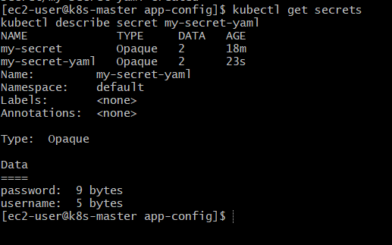

Step 3: Create Pod YAML (Mount Secret as Volume)
Create file:
vi secret-pod-volume.yaml

Paste this:

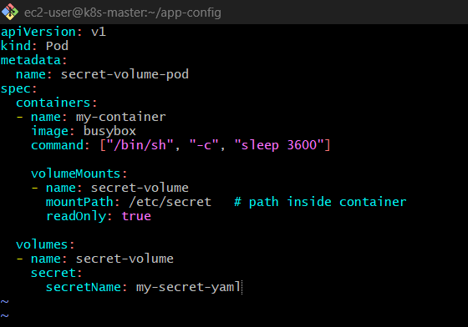

apiVersion: v1
kind: Pod
metadata:
name: secret-volume-pod
spec:
containers:
- name: my-container
image: busybox
command: ["/bin/sh", "-c", "sleep 3600"]
volumeMounts:
- name: secret-volume
mountPath: /etc/secret # path inside container
readOnly: true
volumes:
- name: secret-volume
secret:
secretName: my-secret-yaml

Step 4: Apply Pod
kubectl apply -f secret-pod-volume.yaml
kubectl get pods

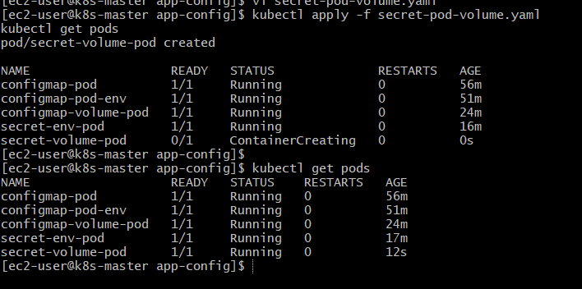

Step 5: Verify Secret as Files
Enter pod:
kubectl exec -it secret-volume-pod – sh

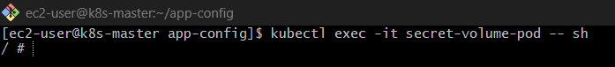
Check directory:
cd /etc/secret
ls
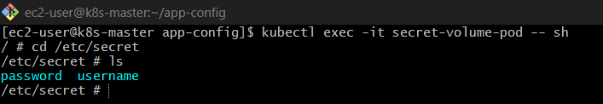
👉 Output:
username
password

Step 6: Check file contents
cat username
cat password

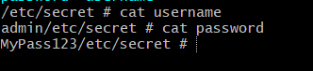
👉 Output:
admin
MyPass123

Key Concept
- Secret keys → become file names
- Secret values → become file content (decoded automatically)

Bonus: Mount only specific key
volumes:
- name: secret-volume
secret:
secretName: my-secret-yaml
items:
- key: username
path: user.txt
👉 Now inside container:
/etc/secret/user.txt

What this means (simple logic)
👉 Inside your Secret:
data:
username: YWRtaW4=
password: TXlQYXNzMTIz

Default behavior (WITHOUT items)
If you don’t use items:
/etc/secret/
├── username
└── password

With items (your case)
items:
- key: username
path: user.txt
👉 Now Kubernetes will:
✔ Take only username key
✔ Ignore password
✔ Rename file to user.txt
Final result inside container
/etc/secret/
└── user.txt
File content
cat /etc/secret/user.txt
👉 Output:
admin

Pod YAML
apiVersion: v1
kind: Pod
metadata:
name: secret-items-pod
spec:
containers:
- name: my-container
image: busybox
command: ["/bin/sh", "-c", "sleep 3600"]
volumeMounts:
- name: secret-volume
mountPath: /etc/secret
volumes:
- name: secret-volume
secret:
secretName: my-secret-yaml
items:
- key: username
path: user.txt
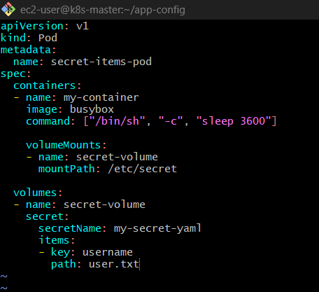

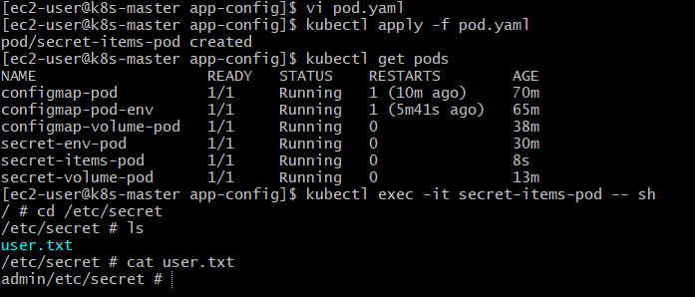

What Happened Internally
- Secret has 2 keys → username, password
- You used items → selected only username
- Renamed it → user.txt
- Mounted → /etc/secret/user.txt

Important Rules
✔ key → must exist in Secret
❌ If wrong → Pod will NOT start
✔ path → file name inside container
✔ Only listed keys are mounted
👉 Others are ignored

Important Notes
✔ Secret data stored as base64 (not encrypted by default)
✔ Mounted files are read-only
✔ Kubernetes automatically decodes base64 when mounted

Final Summary
Step | What Happens
Secret YAML | Stores encoded data
Volume | Links secret to pod
Mount | Exposes as files
Inside Pod | Files contain decoded values

5) Inject a ConfigMap as environment variables and a Secret as files into the same pod, ensuring both are accessible within the pod.

Step 1: Create ConfigMap (for env variables)
kubectl create configmap app-config \
--from-literal=APP_MODE=production \
--from-literal=APP_COLOR=blue \
--dry-run=client -o yaml | kubectl apply -f –

👉 This will:
- Create if not exists ✅
- Update if exists ✅
👉 Verify:
kubectl describe configmap app-config

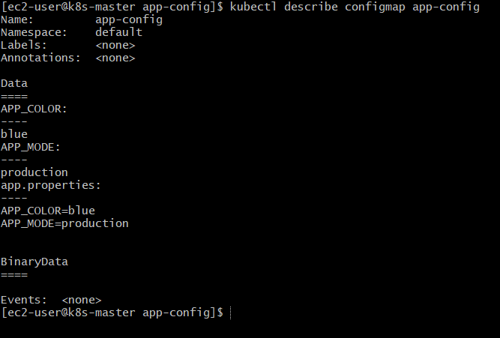

Step 2: Create Secret (for files)
kubectl create secret generic app-secret \
--from-literal=username=admin \
--from-literal=password=MyPass123

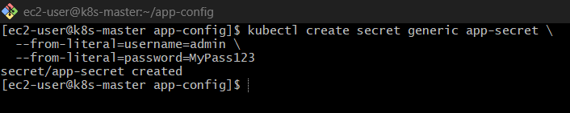
👉 Verify:
kubectl describe secret app-secret

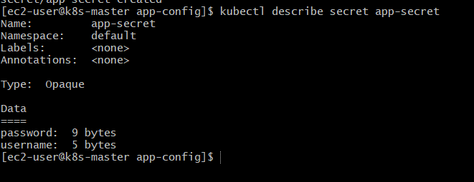

Step 3: Create Pod YAML
vi combined-pod.yaml
Paste this:
apiVersion: v1
kind: Pod
metadata:
name: config-secret-pod
spec:
containers:
- name: my-container
image: busybox
command: ["/bin/sh", "-c", "env && sleep 3600"]
# 🔹 ConfigMap as ENV
envFrom:
- configMapRef:
name: app-config
# 🔹 Secret as FILES
volumeMounts:
- name: secret-volume
mountPath: /etc/secret
readOnly: true
volumes:
- name: secret-volume
secret:
secretName: app-secret

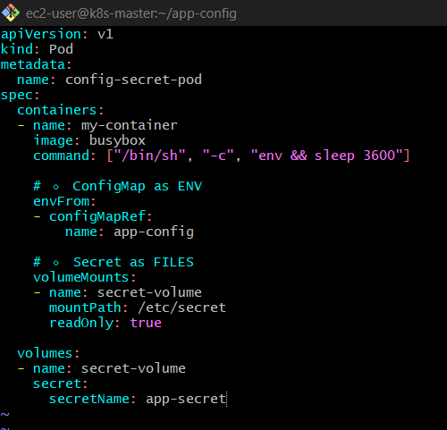

Step 4: Apply Pod
kubectl apply -f combined-pod.yaml
kubectl get pods
Wait until Running

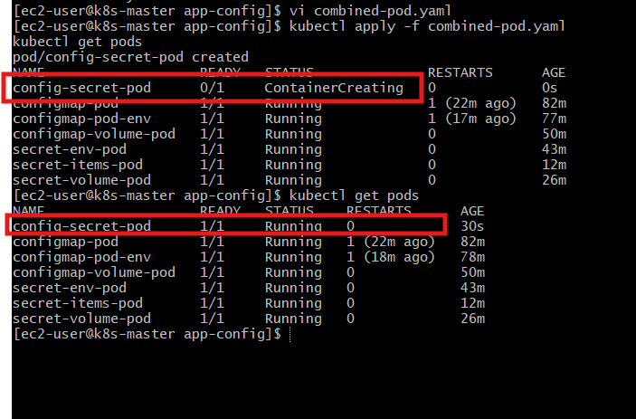

Step 5: Verify ConfigMap (Environment Variables)
kubectl exec -it config-secret-pod – env

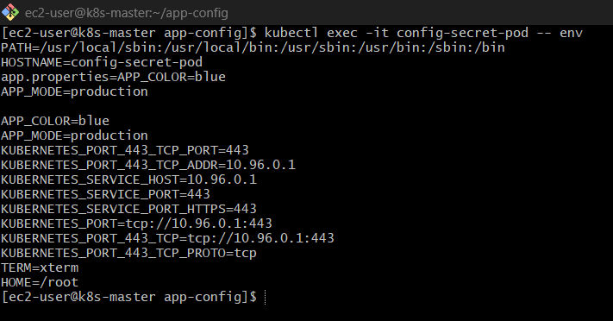
👉 Output will include:
APP_MODE=production
APP_COLOR=blue

Step 6: Verify Secret (Files)
kubectl exec -it config-secret-pod – sh

Inside container:
cd /etc/secret
ls

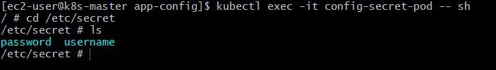
👉 Output:
username
password
Check values:
cat username
cat password
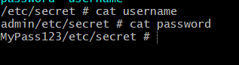
👉 Output:
admin
MyPass123

What You Achieved
Resource |  |  | Injection Type |  |  | Result
ConfigMap |  |  | Environment variables |  |  | APP_MODE, APP_COLOR
Secret |  |  | Volume (files) |  |  | /etc/secret/username, /etc/secret/password

